1. 
2. 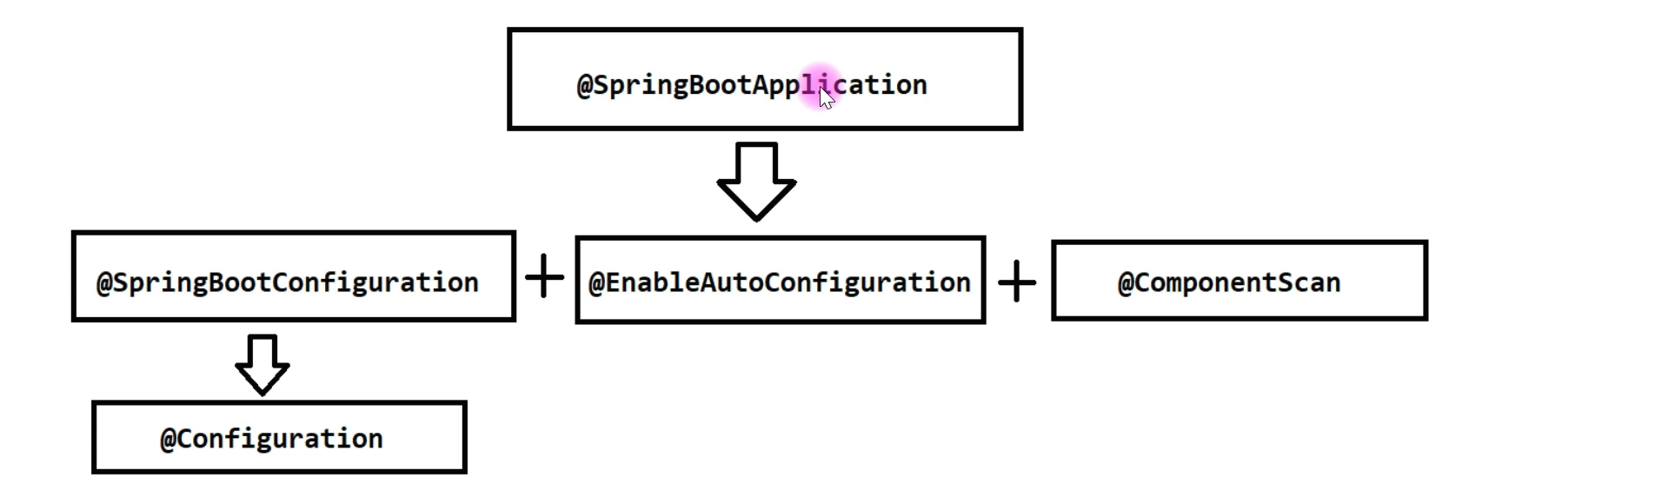
3. @Configuration:
   1. To trigger Java-Based Configuration.
   2. There are 3 kinds of Configurations.
      1. XML-Based.
      2. Java-Based: Use @Configuration
      3. Annotation-Based.
4. @EnableAutoConfiguration:
5. @ComponentScan:
   1. Current Package and sub-packages.
   2. Example:  
      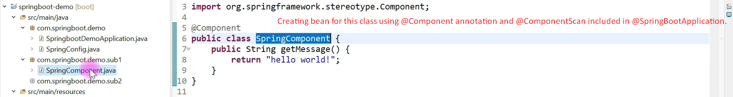
   3. 